1. 
2. **Section Agenda**:
   1. What is JSONPath?
3. Let’s try to understand DB to understand JSONPath.
4. 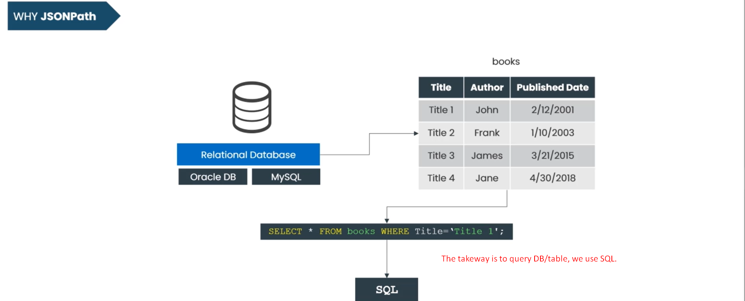
5. **JSONPath**:
   1. A Query Language to extract data from a JSON File.
   2. **JSONPath** acts similar to **XPath** in XML and **SQL** in DB.
   3. Diagram

      Description automatically generated with medium confidence
6. The data in JSON Doc is placed in **hierarchy structure**.
   1. So, at the top level, we have **Root Node/element** a node containing all other **JSON Code.**
   2. Other **nodes** are **child nodes** of the **root node**.
7. So, to extract the subset of the data in JSON Doc, we need **JSONPath.**
   1. Let’s try to understand this by an example.
   2. The following is the simple Kubernetes **Pod Configuration** in JSON format.
      1. This **pod** consists of two containers consisting of **Nginx and Redis Containers**.
      2. 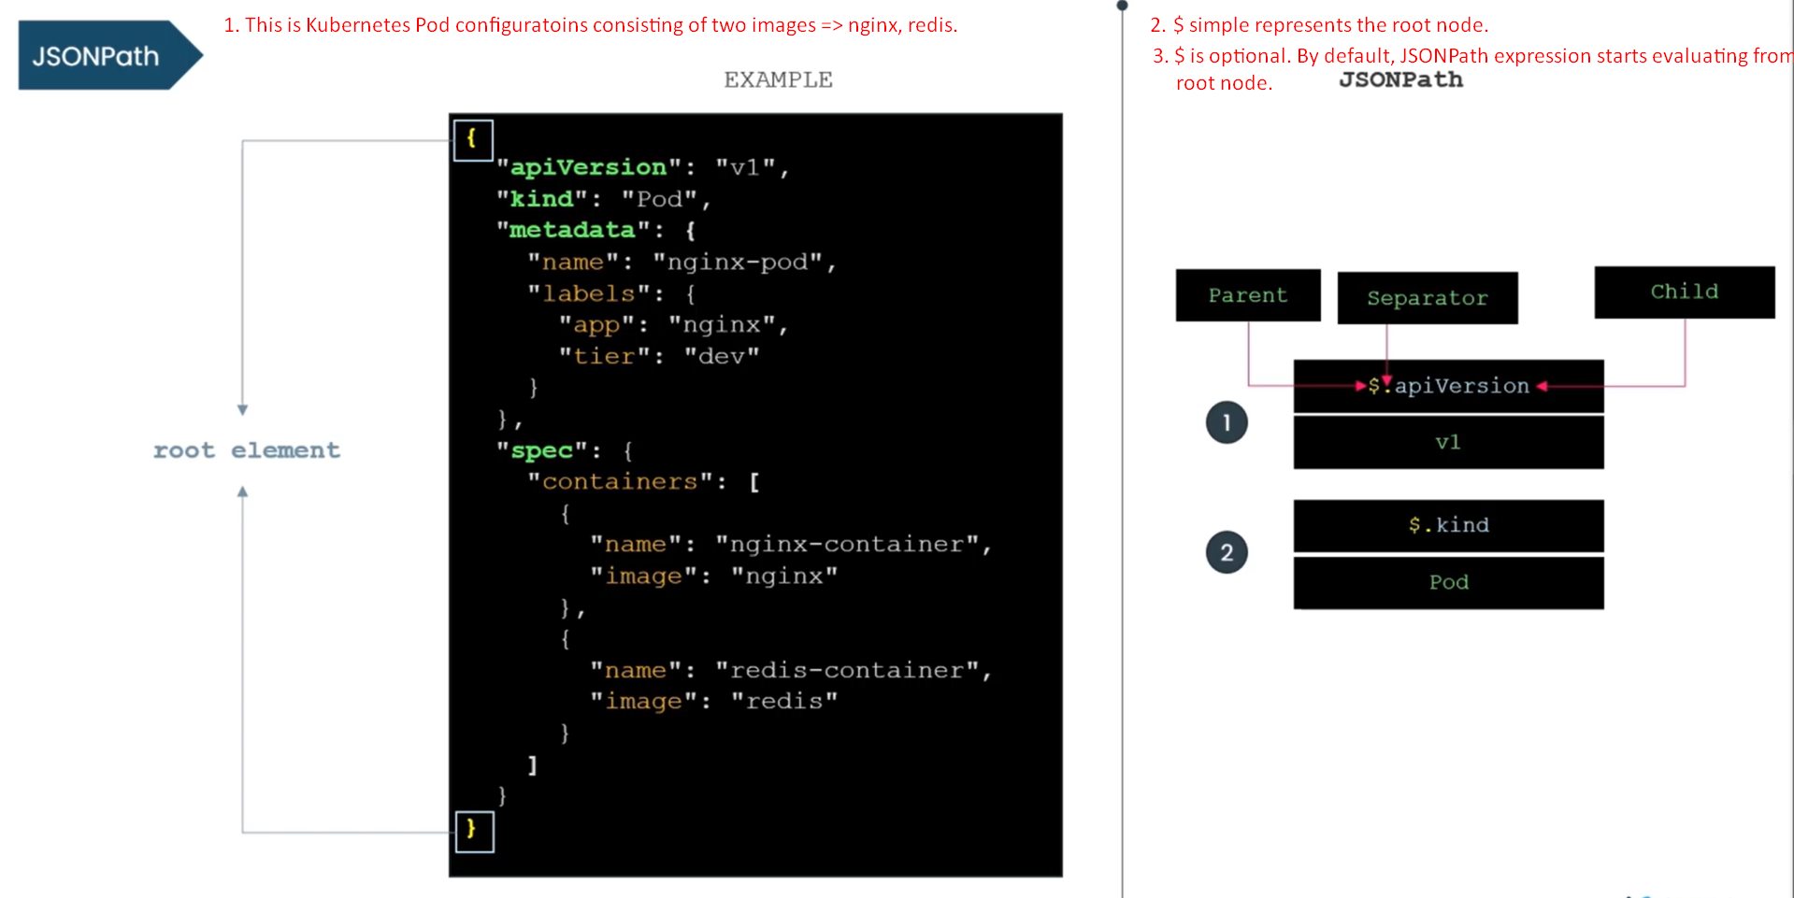
      3. $: Represents the root element of the JSON Doc.
      4. In the upcoming lectures, we will see complex JSONPath Expressions.
         1. Dictionary.
         2. List.
         3. Criteria.
         4. Wildcard.